How to check progress following a Referral for Financial Assessment Request

From the 7th February 2022 you will be able to see on Mosaic how a financial assessment is progressing on a person’s record by looking at the Person Record Current Work and checking if there is an open Financial Assessment Request.
If there is, you can click on the Financial Assessment Request to the right of the 3 icons.
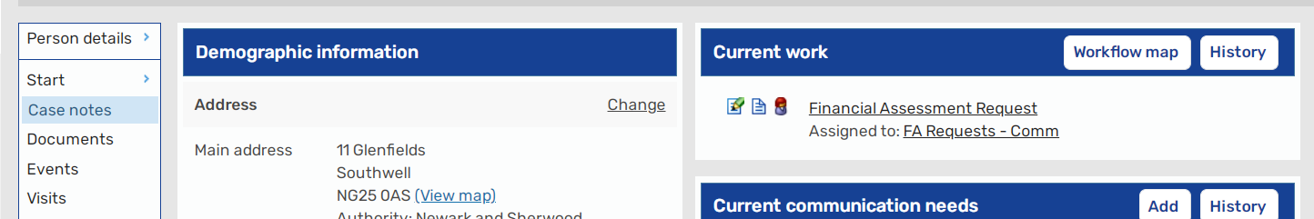

From this screen you can click on View to open the step and view the Financial Assessment Status form.
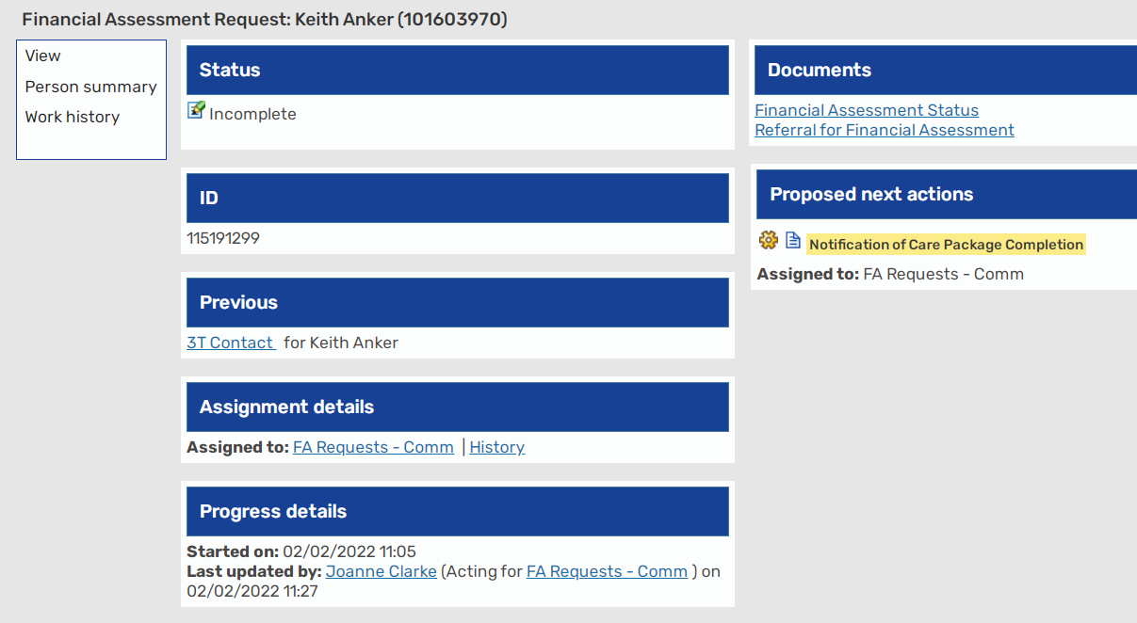

This form is maintained by ACFS (Adult Care Financial Services) staff and is updated as an assessment proceeds.
You cannot edit this form or make any changes to this step but you can output the form to PDF for emailing or printing should the need arise.
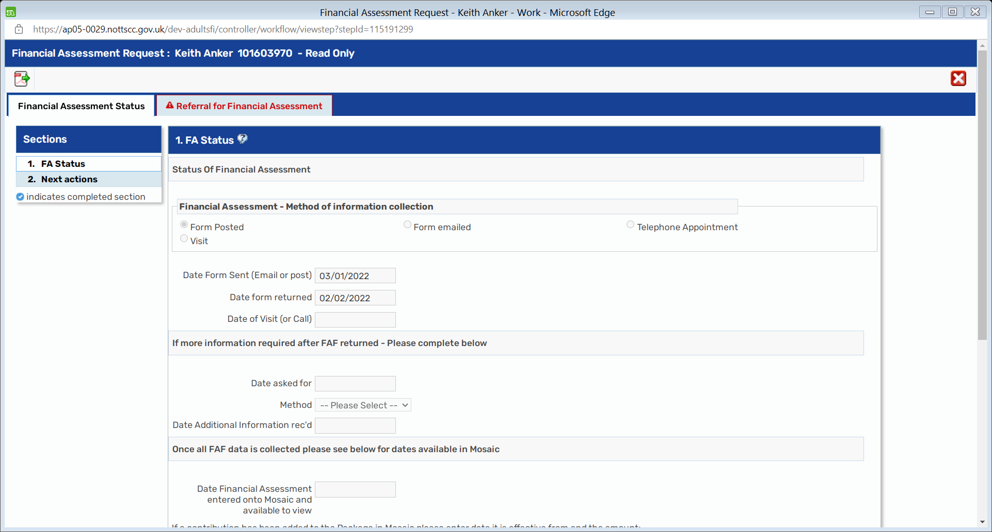
On completion of the Financial Assessment the Worker who requested the financial assessment will be notified of the outcome and this step will be closed. At that point if a contribution is applied it will show on the person’s package of care.
To exit the Step – please use the RED X in the top righthand corner

